Git Hub : https://github.com/mankumarbhalodiya/Digital-Signal-and-Image-Processing
Aim : Simulate smoothing and sharpening operations on images using frequency domain filters.

Code :
import cv2
import numpy as np
import matplotlib.pyplot as plt
img = cv2.imread("images.jpeg", cv2.IMREAD_GRAYSCALE)
F = np.fft.fftshift(np.fft.fft2(img))
M, N = img.shape
u, v = np.meshgrid(np.arange(N)-N//2, np.arange(M)-M//2)
D = np.sqrt(u**2 + v**2)
LPF = D < 30
HPF = D >= 30
smooth = np.abs(np.fft.ifft2(np.fft.ifftshift(F * LPF)))
high_pass = np.abs(np.fft.ifft2(np.fft.ifftshift(F * HPF)))
sharp = np.clip(img.astype(float) + high_pass, 0, 255)
plt.figure(figsize=(12, 4))
plt.subplot(1, 3, 1)
plt.imshow(img, cmap='gray')
plt.title('Original Image')
plt.axis('off')
plt.subplot(1, 3, 2)
plt.imshow(smooth, cmap='gray')
plt.title('LPF - Smoothening')
plt.axis('off')
plt.subplot(1, 3, 3)
plt.imshow(sharp, cmap='gray')
plt.title('HPF - Sharpening')
plt.axis('off')
plt.show()

Output :
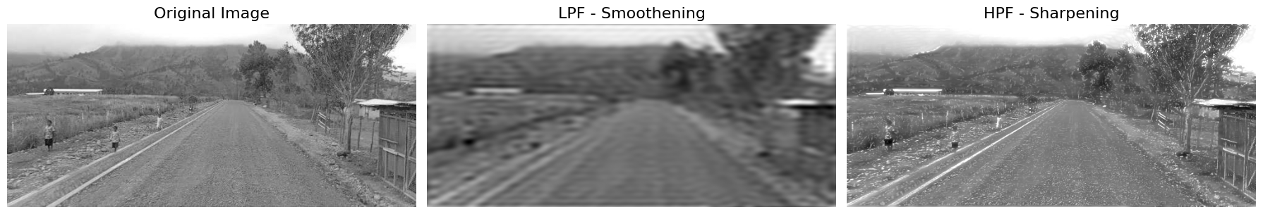
LPF = D < 100
HPF = D >= 100
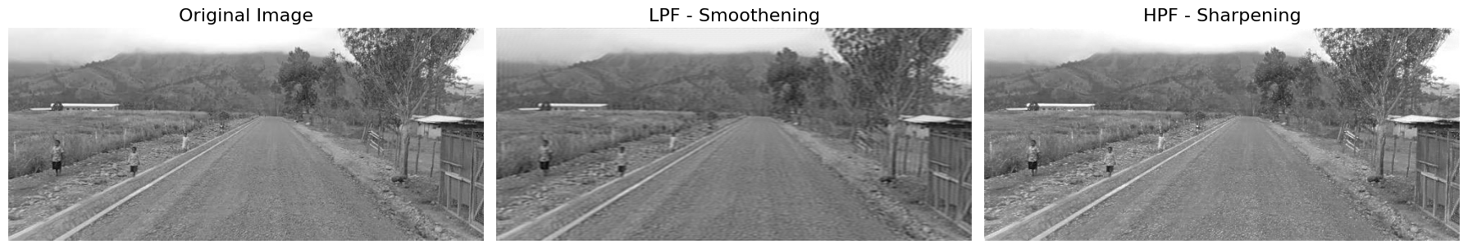

LPF = D < 10
HPF = D >= 10
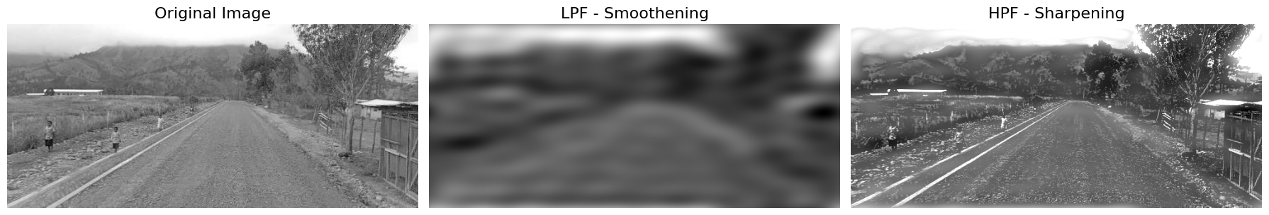

Conclusion : In this experiment, we used Fourier Transform to apply low-pass and high-pass filters to an image. The low-pass filter made the image smoother by reducing fine details and noise, while the high-pass filter highlighted edges and sharpened the image. Through this experiment, we understood how frequency domain filtering helps improve and analyze images.

